**Lab 13**

1. Install and activate the Theme in wordpress.

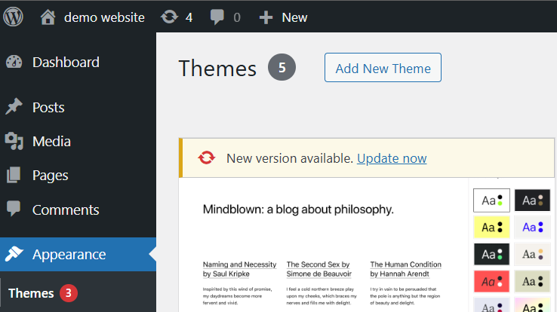

1. Create 2-3 different pages using different themes.





1. Install and activate various Plugins in WordPress. Create content writing for E commerce sites and product description that sells online. Install and activate 2 various Plugins in WordPress. Design coupon code for selling product and upload stock of item on site

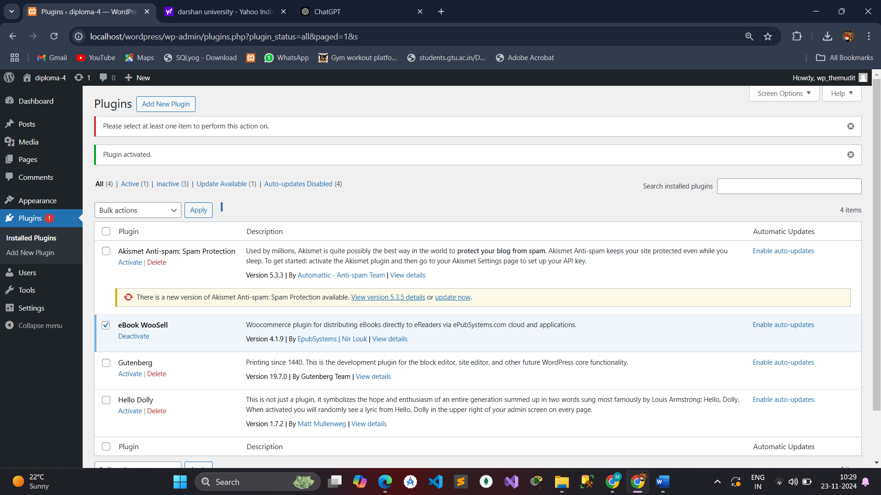

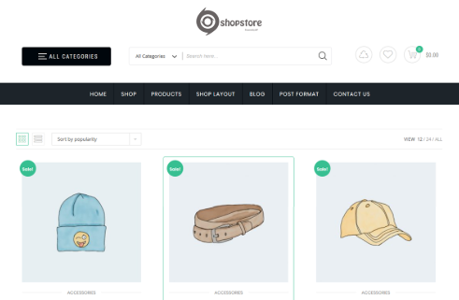

1. Create a travelling website using various plugins.

